PRESS RELEASE
R+T 2018

Pergola automation for all weathers
Linear actuator with compact construction and quiet operation / Intelligent radio control reacts to light, frost, storm and rain

Schlierbach/Stuttgart – In the linear actuator sector elero is presenting two new products at R+T 2018: the Patio drive and the control unit Patio Control. In combination with this duo pergolas offer protection against excessive solar radiation and rain, distribute daylight as desired, and can be operated comfortably via a radio hand-held transmitter. In addition, weather sensors, LED lighting and side shading may also be integrated.

Quiet, short linear actuators move the pergola slats
The powerful, electromechanical linear actuator Patio is convincing thanks to its short and compact construction, which allows it to be used in pergolas from a large number of manufacturers. Quiet operation ensures an outdoor sojourn is also a relaxing one. It is available with fixed stroke lengths as well as customer-specific lengths. The linear actuator Picolo 0 used to date for pergola motorisation remains a good solution. The attractive, slender drive made of anodised aluminium is also suited to visible installation. Thanks to its IP 67 protection class it is immune to the effects of wind and rain.

Control prevents the slats freezing in position
The control unit Patio Control comprises a slender housing and a power supply unit that is easily connected to the domestic mains supply. The end positions and the running time are learnt independently by the control. In the event of rain the sensor’s rain function comes into play, informing the control that the slats need to be closed. After a downpour the slats are opened again, the raindrop function ensures these come to a rest at an angle of 20 degrees. At temperatures below 2 °C the pergola slats are opened by 3 degrees after the slats have been closed so as to prevent them from freezing in position.

A complete control system
The control unit Patio Control combines several elements with one another, with the effect that it is also possible to operate lighting or additional textile hangings with hand-held or wall-mounted transmitters, for example. Automatic shading control by the weather sensor Sensero-868 AC Plus adjusts the position of the slats in accordance with the current light, twilight, wind and weather conditions, and closes the slats in the event of rain. It a strong wind picks up, the slats are opened to avoid damage to them. A temperature sensor is already supplied as standard with Patio Control. If Sensero registers rain and the outside temperature falls below 1 °C, it is assumed there will be snow. The slats are then opened so that the pergola cannot be damaged by the snow load.

A lighting module with four outputs may be combined as optional with the control unit Patio Control. Each channel can switch lamps on and off, as well as dimming them using 24 lighting levels. This allows for new design options and individualised lighting situations. Compatible hand-held transmitters, timer switches and wall-mounted transmitters from elero ensure ease of operation. With the aid of Centero Home, the pergola system can be controlled via a tablet or smartphone if so desired.

Zeichen Fließtext (ohne Abbinder, inkl. Leerzeichen): 3.033

About elero
elero, domiciled in Schlierbach near Stuttgart, is one of the world’s largest manufacturers of electric motors and controls for roller shutters, sun protection systems and rolling doors. A second business division develops and produces electric linear actuators. With 430 employees worldwide the company generated sales of 75 million euros in 2016. The drive manufacturer is a wholly-owned subsidiary and independent premium brand for screen automation solutions within the Italian group of companies The Nice Group.

Photos:

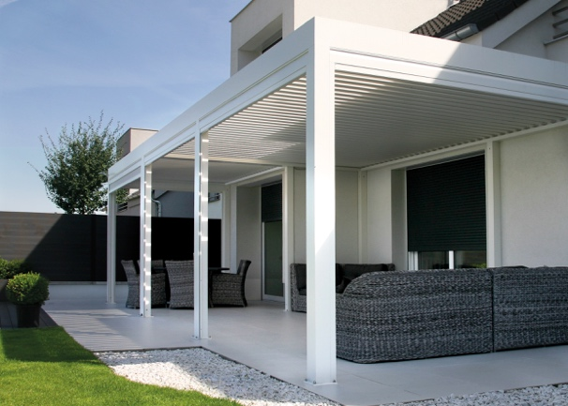
The intelligent control unit Patio Control reacts to light, frost, storm and rain. (Photo: alaris)

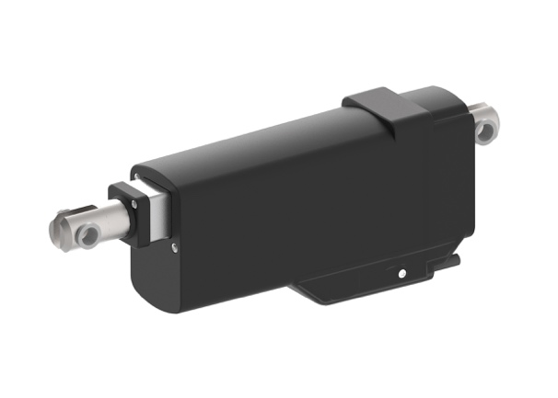
The powerful, electromechanical linear actuator Patio is suitable for slats made of aluminum, glass, stainless steel or wood. (Photo: elero GmbH)

The text and photos to this press release are available for download under presseportal.brandrevier.com/elero.

Contact:  Inge Rappold  Tel: +49 7021 9539-100  Mail: inge.rappold@elero.de  elero GmbH  Maybachstraße 30  D-73278 Schlierbach | Editorial office:  Tobias Nazemi  Tel: +49 201 8742 9311  Mail: nazemi@brandrevier.com  Brandrevier GmbH  Gemarkenstr. 138a  D-45147 Essen

